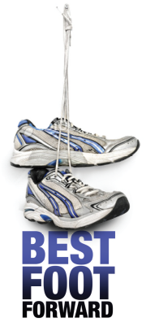 | A community initiative, devised and organised by  The Rotary Club of the City of Wolverhampton  and supported by  Wolverhampton City Council, the Express & Star and The James Beattie Charitable Trust

My name is……………………………………………………………………………………………………………….

Address…………………………………………..…………….……………..……… Post code………….………..….…..……

and I am putting my best foot forward
at Aldersley Leisure Village, on Saturday June 29th 2024, to raise funds for

..........................……………………………………………
Registered Charity No:……………

Sponsor’s Declaration
I have ticked the column for Gift Aid to be claimed, and confirm that I have paid or will pay an amount of Income Tax and/or Capital Gains Tax for the current tax year that is at least equal to the amount of tax that the charity will reclaim on my sponsorship at the rate of 25p of tax on every £1 that I have given. I understand that if I pay less Income Tax and/or Capital gains Tax than the amount of Gift Aid claimed on all my Donations, it is my responsibility to pay any difference.
I understand that other taxes such as VAT and Council Tax do not qualify.
Sponsor  (First name & surname) |  | Donation  £ | Date  Paid | Tax Payers  √ for  Gift Aid | Only if you are Gift Aiding your Donation
 |  |  |  |  | House Nº/Name  Do NOT put your work address. | Post Code
Total donations collected |  | £
Total Gift Aided donations |  | £
Date paid to Charity

